Code: https://colab.research.google.com/drive/1EFxeBsRFiKMXpjM1-tlA3hL_-a7wKKWz?authuser=1#scrollTo=S6YLUNF23kuF
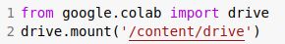 | Mount the Google drive to import video files from it.
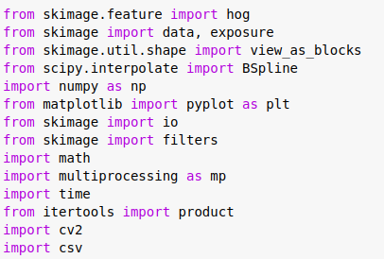 | - Skimage from scikit is a python package used to calculate the HOG vector values of the images.  - View_as_blocks is used to converd 2D array to array for each block with desired dimention.  - filters is for sobel filters.
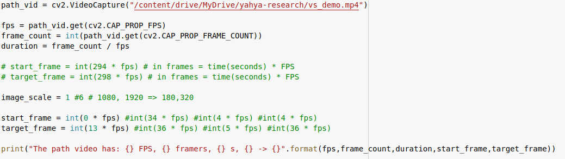 | - path_vid is the path to video file to be processed.  - fps is used to store the FPS of video file.  - duration is the duration of the file  - Image_scale is used in case a scale is needed to input image.  - start_frame/end_frame are used to specify the number of initial frame and last frame to process.
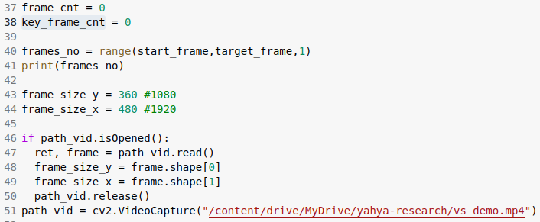 | - frame_cnt is used as a counter of processed frames.  - frames_no is a list for frames number to be processed in the code. Change the 3rd argument to control the interval between frames.  - frame_size_x/y are the dimension of input images and they are exported from the file used.
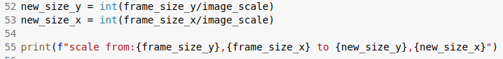 | new_size_x/y are the size after scaling using the image_scale variable value.
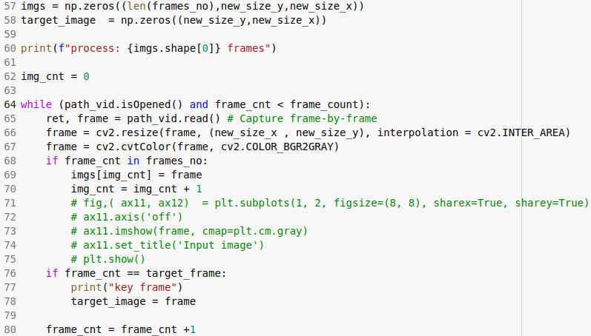 | This block is reading the frames we want and store it to an array called imgs. The read process include resizing and convert the image to gray colore mode.  We store the last frame as the target frame in target_frame.
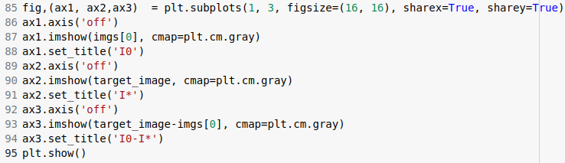 | This will plot the initial image I0 and target image I* and the difference between the pixels value of both (I0-I*)
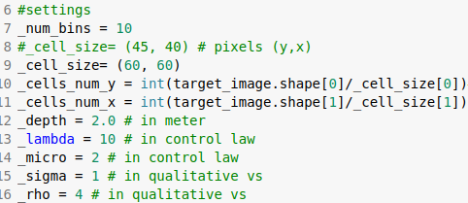 | Here are the settings used to fine-tune the control law:  - _num_bins: the number of bins in HOG histogram.  - _cell_size: the size of cell in pixels in HOG.  - _cells_num_y/x how many cells we have in x/y axis.  - _depth it is the estimated depth of projected pixel in the image in meters found in Lx matrix (Z value):  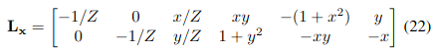  - _lambda and _micro are the parameters in the last control law  - _sigma and _rho are the parameters in the activation function in qualitative visual serviong law  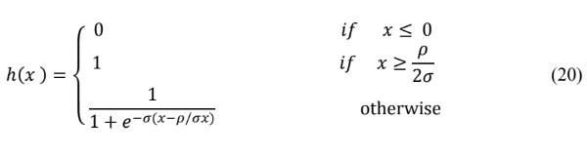
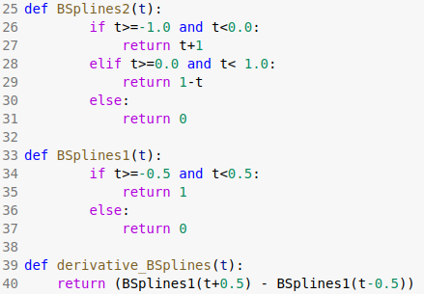 | These are the functions used in the original paper equations math develpoment  These functions are stated in the author thesis(https://www.theses.fr/2018REN1S006/abes) page 55:  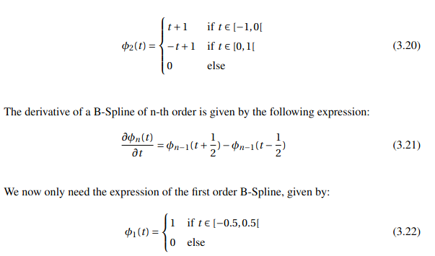
 | derivative_BSplines_vec and BSplines2_vec are a vectroised version of the functions presented in the previous cell. This will allow to take the argument t as a numpy array. This technique is used to enhance the code speed. Instead of applying the function on value by value you can apply on a matrix in one shoot and numpy will loop through using enhanced and optimized way. More about vectorization here.
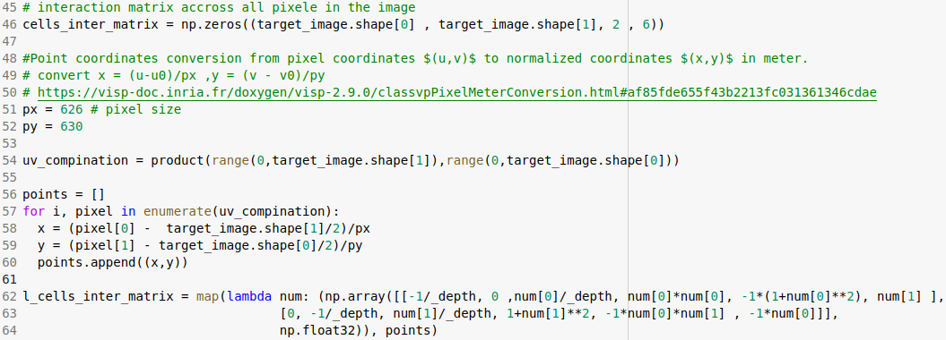 | Interaction matrix for each pixel as defined here  x,y are in point coordinates conversion from pixel coordinates (u,v) to normalized coordinates (x,y) in meter.  - uv_compination is a list of all combination of pixel coordinated {[0,0], [1,0], …. [image_width,image_hight]}  - The for loop is doing the conversion of each (u,v) to (x,y) using the following converter  x = (u-u0)/px ,y = (v - v0)/py  - p_x and p_y are pixel size. I used the pixel size of the mobile camera.
 | Here we reshape the list of interaction matrix Lx of each pixel from a list with length image_width*image_length to an blocks of arrays. The block number in x and y are defined perfore.
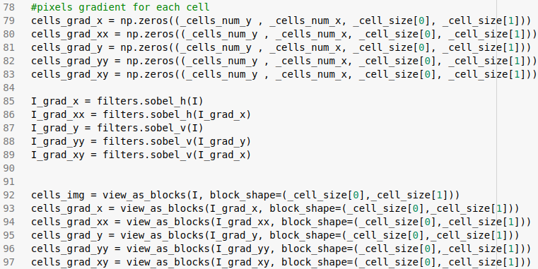 | - cells_grad_x/y/xx/yx/xy are used to store the gradient value of each pixel in each cell.  - I_gradx/xx/y/yy/xy are the acual gradient using sobel filter over x/y/xx/yx/yx.
cells_grad_y_over_x is the following variable in the original work :

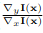

cells_grad_one_plus_pow_y_over_x is the following variable in the original work :

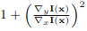
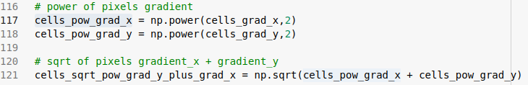 | They are for:  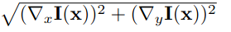
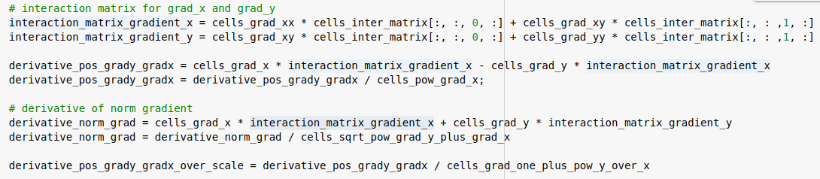 | There are for finding the following:  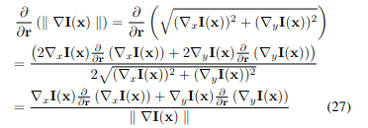  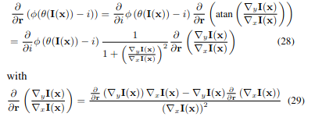
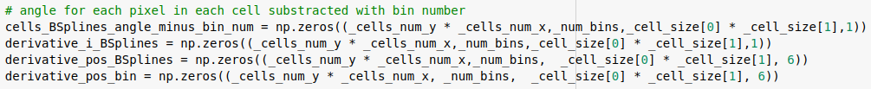 | Initiate these variables which are used in calculating the  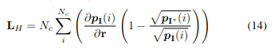  And  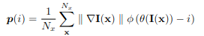  For example cells_BSplines_angle_minus_bin_num will be used to store the value of for each pixel.
 | Pixel direction (angle) for each cell. This way of calculating the direction is found in the original code.
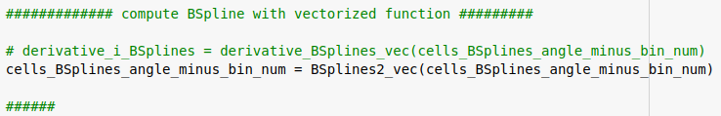 | We compute the following derivative using the verctroized function I introduced before in the table:  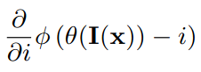  Lines from 151 - 225 are for an alternative way of applying the functions  On the matrix values without the verctrorized function. Both ways are identical, but verctroized functions are faster.
Thery are for:
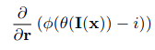
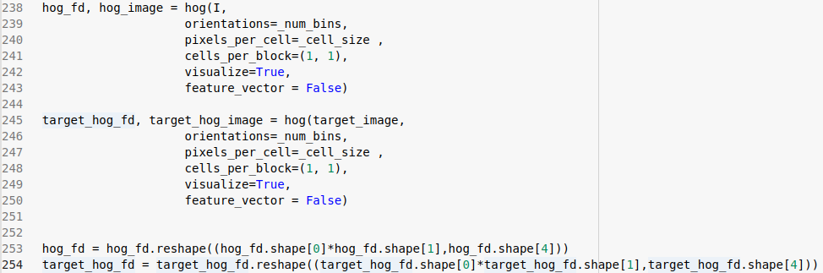 | Finding the HOF feature vector using scimage python package.
 | Distance of current image under processing and the target image
 | 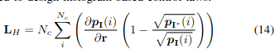
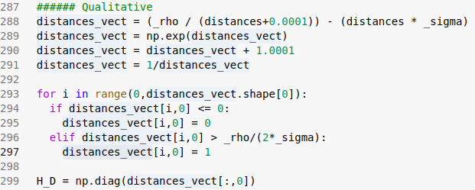 | Here I find the diagonal matrix proposed in the qualitative part. First find the distance between each cell and the corresponding target image cell and then applying the activation function h(x)  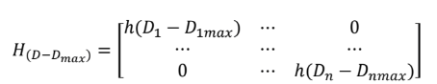  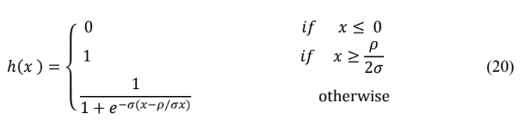
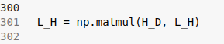 | Here is finding what is called in the Tubitak report Lq, which will be used in the final law. It is the product of the diagonal matrix with the matrix Lh found in the original HBVS work.  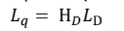
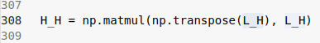  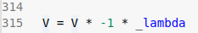 | Here is finally finding the velocity according to this law  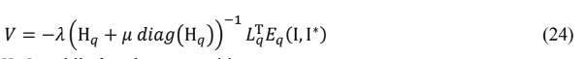  H_H is the Lq multiplies with its transpose.  